DEPARTMENT OF INTERIOR DESIGN & DECOR

SL. NO. | NAME OF THE STAFF | DESIGNATION
1 | V.Yasodha, M.Phil., Net | HEAD OF THE DEPARTMENT
2 | N.Aarthi,B.E Civil., | ASSISTANT PROFESSOR
3 | J.Dhanalakshmi, M.Sc ., Mphil.,B.Ed., | ASSISTANT PROFESSOR
4 | Miss.Kalyani Deka,M.Sc.,NET., | ASSISTANT PROFESSOR
5 | C.Vino Rajathi.,MBA., | ASSISTANT PROFESSOR
6 | Ms.R.Monica,M.Sc., | ASSISTANT PROFESSOR
7 | Miss.A. Nilufar Banu,B.A.,BCA.,M.Sc., | ASSISTANT PROFESSOR

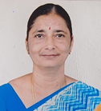

PERSONAL PROFILE

Name | V. YASODHA
Designation | Assistant Professor and Head
Father’s name | N.C.Venkidusamy
Date of Birth | 09.06.1972
Address for Communication
Office | Department of Interior Design and Décor
 | M.M.E.S. Women’s Arts And Science College
 | Hakeem Nagar, Melvisharam
 | Ranipet District – 632509
Home | 29/4, Chellappa Gardens
 | Dr. Rajendra Prasad Street
 | Perundurai
 | Erode district – 638052
Email id. | yasodhavenkidusamy@gmail.com
Contact Number
Office
Personal | 9486923442

SCHOLISTIC PROFILE

Educational  Qualification | Institution / University | Year of  passing
S. S. L. C. | Govt. Girls. Higher Secondary School, Perundurai | 1987
H. S. C. | Govt. Girls Higher Secondary School,  Perundurai | 1989
B.Sc. Nutrition and Dietetics | Vellalar College for Women,. Erode | 1993
M.Sc., Family Resource Management | Avinashingam Deemed University, Coimbatore | 1995
M.Phil., Family Resource  Management | Avinashingam Deemed University,  Coimbatore | 1997
UGC NET in Home Science | University Grants Commission | 1998 and 2004

DISSERTATION AND THESIS

COURSE | TITLE | INSTITUTION | YEAR
M.Phil. | Attitude of Women Towards Employment | Avinashilingam Deemed University | 1997

TEACHING EXPERIENCE
S.No. | INSTITUTION | From | To | No. of Years
1. | Sree Amman Arts and Science College, Erode | 1.9.95 | 4.4.96 | 7 months
2. | Maharaja Co-Education Arts and science college, Perundurai | 1.12.97 | 31.3.2014 | 16years  4 m onths
3. | M.M.E.S. Women’s Arts and Science College, Melvisharam |  | Till Date

BOOKS/ PAPER PUBLISHED

S.No | TITLE | ISBN NUMBER | Year
1 | An Adaptable Technology to Treat Waste- Biogas Plant  In the Edited Book of 33rd Biennial Conference of Home Science Association of India on Trends for futuristic development in Home Science: Research and Innovation | ISBN 978-93-85604-13-3 | 22nd – 24 th January 2020
2 | Women Entrepreneurship:  The Influence of family background on college students involvement in entrepreneurship. | ISBN 978-93-92537-40-0 | December 1st & 2nd 2022
Board of Studies (Subject Expert)

S.No. | College | Programme | Year
1 | Thiruvalluvar University | Member of the Board of Studies in B.Sc., Interior Design and Décor and M.Sc., Interior Design and Décor | 24.10.20 to 23.10.23
2 | Bharathiar University | Chair person for Board of Studies  in B.Sc. Interior Design | 20.4. 2004 to  31.12.12

Faculty Development Programme
S.No. | College | Tile | Year
1 | C Abdul Hakeem College of Engineering And Technology | 3 days international faculty development programme on  “ Re- Vitalizing Education during Pandemic & Beyond” | July 23rd -25th 2021
2 | M.M.E.S WOMEN’S ARTS AND SCIENCE COLLEGE | Two days state level FDP on Recent Trends in Information Technology | 26th & 27th August 2021
3 | Hindusthan College of arts and science | “Digital teaching methods in higher education” | 23rd to 28th August 2021
4 | SENGUNTHAR ARTS AND SCIENCE COLLEGE | “The importance of emotional intelligence for teachers” | 29th may 2020

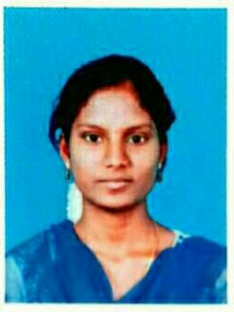

PERSONAL PROFILE

Name | N. Aarthi
Designation | Assistant professor
Father’s name | C. Neelagandan
Date of Birth | 05/01/1998
Address for Communication
Office | Department of Interior Design and Decor  M.M.E.S Women's Arts and Science College,  Hakeem nagar, Melvisharam.  Tamil Nadu- 632509
Home | No. 100,  New street, Manthangal,  Gandhinagar, Ranipet -632404.
Email id. | aarthyneelagandan05@gmail.com
Contact Number
Office
Personal | 7358868198

SCHOLISTIC PROFILE

Educational  Qualification | Institution / University | Year of  passing
S.S.L.C | VRV Girls.Hr. Sec. School, Ranipet | 2013
H.SC | VRV Girls.Hr. Sec. School, Ranipet | 2015
B.E., Civil | Anna University | 2019

TEACHING EXPERIENCE

S.No | INSTITUTION | From | To | No. of Years
1. | M.M.E.S Women's Arts and Science College | 2019 | Till | -

BOOKS/ PAPER PUBLISHED

S.No. | TITLE | ISBN NUMBER | Year
1 | Women Entrepreneurship:  A study on challenges faced by women entrepreneurs of college students | ISBN 978-93-92537-40-0 | December 1st & 2nd 2022

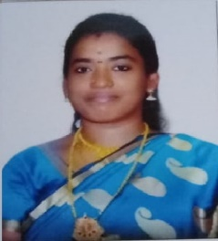

PERSONAL PROFILE

Name | J.DHANALAKSHMI
Designation | Assistant Professor
Father’s name | T.N.JANARTHANAN
Date of Birth | 10.11.1988
Address for Communication
Office | Department of Interior Design and Décor
 | M.M.E.S. Women’s Arts And Science College
 | Hakeem Nagar, Melvisharam
 | Ranipet District – 632509
Home | 28/16,BERI CHETTY STREET
 | THIMIRI -632 512
 | ARCOT TALUK
 | RANIPET DISTRICT
Email id. | j.dhanalakshmi88@gmail.com
Contact Number
Office
Personal | 9884029022

SCHOLISTIC PROFILE

Educational  Qualification | Institution / University | Year of  Passing
S. S. L. C. | Govt. Girls. Higher Secondary School, Perambur | 2004
H. S. C. | Govt. Girls Higher Secondary School,  Perambur | 2006
B.Sc. Nutrition and Dietetics | University of Madras | 2009
M.Sc., Family Resource Management | University of Madras | 2011
M.Phil., Family Resource  Management | University of madras | 2012
B.Ed.,(Home Science) | TamilNadu Teachers Education University | 2015

DISSERTATION AND THESIS

COURSE | TITLE | INSTITUTION | YEAR
M.Phil. | A Study on the Quality of Work Life of Women in Organized sector | University of Madras | 2012

TEACHING EXPERIENCE
S.No. | INSTITUTION | From | To | No. of Years
1. | Sri Kannyaka Parameshwari Women’s Arts and Science College | 01.06.2018 | 31.05.2019 | 1 year
2. | M.M.E.S. Women’s Arts and  Science College, Melvisharam | 01.10.2020 | Till Date | 3 years

BOOKS/ PAPER PUBLISHED
S.NO | TITLE | ISBN NUMBER | Year
1 | Women Entrepreneurship:  A study on challenges faced by women entrepreneurs of college students.  Explore the challenges of motherhood by balancing the personal and professional life as an entrepreneur. | ISBN 978-93-92537-40-0 | December 1st & 2nd 2022

FACULTY DEVELOPMENT PROGRAMME

S.No. | College | Tile | Year
1 | M.M.E.S WOMEN’S ARTS AND SCIENCE COLLEGE | TWO DAYS STATE LEVEL FDP ON RECENT TRENDS IN INFORMATION TECHNOLOGY | 26TH & 27TH AUGUST 2021
2 | SHRI SHANKARLAL SUNDABAI SHASHUN JAIN COLLEGE FOR WOMEN | “HOW TO KEEP YOUSELF ENERGIZED THE WHOLE DAY??? LET THE HAPPINESS STAY FOR EVER !!!” | 16TH AUGUST 2021
3 | ICT ACADEMY - M.M.E.S WOMEN’S ARTS AND SCIENCE COLLEGE | THREE DAYS FDP ON CREATIVE THINKING | 21ST &22ND DECEMBER

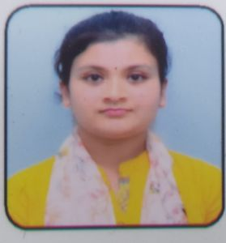

PERSONAL PROFILE

Name | Miss. Kalyani Deka
Designation | Assistant professor
Father’s name | Mr. Srikanta Deka
Date of Birth | 04/11/1991
Address for Communication
Office | MMES College of Arts and Science, Melvisharam,  Tamil Nadu- 632509
Home | #478, Kulhati, District- Kamrup, Assam-781104
Email id. | kalyanideka37@gmail.com
Contact Number
Personal | 6001877119

SCHOLISTIC PROFILE

Educational  Qualification | Institution / University | Year of  passing
M.sc., Resource Management | Smt.V.H.D Central Institute of Home Science | 2017
NET | UGC | 2019

TEACHING EXPERIENCE

S.No. | INSTITUTION | From | To | No. of Years
1. | Smt.V.H.D Central Institute of Home Science | 2017 | 2020 | 2.6
2. | MMES College of Arts and Science | 2021 | Till

Faculty Development Programme

S.No. | College | Tile | Year
1 | M.M.E.S WOMEN’S ARTS AND SCIENCE COLLEGE | Two days state level FDP on Recent Trends in Information Technology | 26th & 27th August 2021

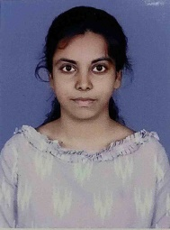

PERSONAL PROFILE

Name | C. Vino Rajathi
Designation | Assistant professor
Father’s name | M Chandran
Date of Birth | 06-07-1997
Address for Communication
Office | Department of Interior Design and Decor  M.M.E.S Women's Arts and Science College,  Hakeem nagar, Melvisharam.  Tamil Nadu- 632509
Home | 28-C, TNHB,  Karai, Ranipet.
Email id. | vinodala06@gmail.com
Contact Number
Office
Personal | 9003739677

SCHOLISTIC PROFILE
Educational  Qualification | Institution / University | Year of  passing
S.S.L.C | Shrishti vidyashram sr. sec School | 2012
H.SC | LFC Girls hr. sec. school | 2014
B.SC., | Thiruvalluvar University | 2018
MBA., | Central University | 2020

TEACHING EXPERIENCE

S.No. | INSTITUTION | From | To | No. of Years
1. | M.M.E.S Women's Arts and Science College | 2021 | Till date

S.NO | TITLE | ISBN NUMBER | Year
1 | Women Entrepreneurship:  A study on challenges faced by women entrepreneurs of college students.  Explore the challenges of motherhood by balancing the personal and professional life as an entrepreneur. | ISBN 978-93-92537-40-0 | December 1st & 2nd 2022

BOOKS PUBLISHED

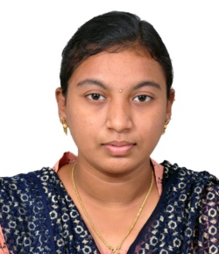

PERSONAL PROFILE

Name | Ms.R.MONICA
Designation | ASSISTANT PROFESSOR
Father’s name | E.RAJAGOPALAN
Date of Birth | 26-04-1999
Address for Communication
Office | MMES WOMEN`S ARTS AND SCIENCE COLLEGE
 | HAKEEM NAGAR ,MELVISHARAM – 632 509
 | RANIPET DISTRICT
Home | NO.45/1257 , PHASE-2 , 5th MAIN ROAD
 | SATHUVACHARI , VELLORE - 632009
Email id. | monicaglitz26@gmail.com
Contact Number
Office
Personal | 8610314188

SCHOLISTIC PROFILE
Educational  Qualification | Institution / University | Year of  passing
SSLC | HOLY CROSS MATRICULATION HIGHER SECONDARY SCHOOL | 2015
HSC | HOLY CROSS MATRICULATION HIGHER SECONDARY SCHOOL | 2017
B.Sc | MMES WOMEN`S ARTS AND SCIENCE COLLEGE | 2020
M.Sc | MMES WOMEN`S ARTS AND SCIENCE COLLEGE | 2022

BOOKS PUBLISHED
S.NO | TITLE | ISBN NUMBER | Year
1 | Women Entrepreneurship:  Explore the challenges of motherhood by balancing the personal and professional life as an entrepreneur. | ISBN 978-93-92537-40-0 | December 1st & 2nd 2022

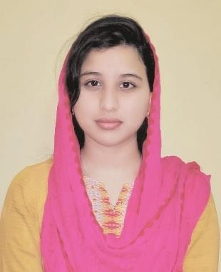

PERSONAL PROFILE

Name | Miss. A. NILUFAR BANU
Designation | ASSISTANT PROFESSOR
Father’s name | R. AKBAR BASHA
Date of Birth | 10/03/1996
Address for Communication | M.M.E.S WOMENS ARTS AND SCIENCE COLLEGE, MELVISHARAM TAMIL NADU – 632509
Home | NO.11 KURINJI NAGAR 1ST STREET SATHUVACHARI, VELLORE 632009
Email id. | nilufarbanu14@gmail.com
Contact Number
Office
Personal | 9600296844

SCHOLISTIC PROFILE

Educational  Qualification | Institution / University | Year of  passing
Diploma in Arabic | National council for promotion of Arabic | 2015
Diploma in Urudu | National council for promotion of Urudu | 2016
B.C.A | TAMILNADU OPEN UNIVERSITY | 2017
B.Sc., Interior Design and Decor | M.M.E.S Womens Arts and Science College, Melvisharam | 2020
B.A Hindi | Dhakshina Bharat Hindi Prachar Sabha | 2020
M.Sc., Interior Design and Decor | M.M.E.S Womens Arts and Science College, Melvisharam | 2022

TEACHING EXPERIENCE
S.No. | INSTITUTION | From | To | No. of Years
1. | MMES WOMEN`S ARTS AND SCIENCE COLLEGE | 29.10.2022

BOOKS PUBLISHED

S.NO | TITLE | ISBN NUMBER | Year
1 | Challenges Of Women Entrepreneurs In The Field Of Beauty Parlour | ISBN 978-93-92537-40-0 | December 1st & 2nd 2022
2 | A Study On Women Entrepreneurs In The Field Of Interior Design

